Subnetting exercises
- How many host addresses are available in the following networks?
IP | Subnet mask in dotted decimal | Network bits | Host bits | # available hosts in the network
151.238.65.128/25 | 255.255.255.128 | 25 | 7 | 126
138.246.224.0/20 | 255.255.240.0 | 20 | 12 | 4094
218.85.109.16/29 | 255.255.255.248 | 29 | 3 | 6
221.123.100.0/27 | 255.255.255.224 | 27 | 5 | 30
28.49.0.0/22 | 255.255.252.0 | 22 | 10 | 1022
216.165.176.64/26 | 255.255.255.192 | 26 | 6 | 62
222.118.173.0/20 | 255.255.240.0 | 20 | 12 | 4094
172.86.156.0/21 | 255.255.248.0 | 21 | 11 | 2046

- Fill in the table using the given IP address
IP | Network  Address | Broadcast  Address | First Host Address | Last Host Address | # available hosts
197.53.96.135/28 | 197.53.96.128 | 197.53.96.143 | 197.53.96.129 | 197.53.96.142 | 14
182.48.180.135/24 | 182.48.180.0 | 182.48.180.255 | 182.48.180.1 | 182.48.180.254 | 254
1.56.237.129/21 | 1.56.232.0 | 1.56.239.255 | 1.56.232.1 | 1.56.239.254 | 2046
12.210.139.230/25 | 2.210.139.128 | 12.210.139.255 | 12.210.139.129 | 12.210.139.254 | 126
111.172.197.153/17 | 111.172.128.0 | 111.172.255.255 | 111.172.128.1 | 111.172.255.254 | 32766
194.99.221.165/27 | 194.99.221.160 | 194.99.221.191 | 194.99.221.161 | 194.99.221.190 | 30
72.1.7.47/22 | 72.1.4.0 | 72.1.7.255 | 72.1.4.1 | 72.1.7.254 | 1022

- A router is configured with the IP address 114.135.225.17/28. Which of the following IP addresses can I use to assign to a host in that network?
IP | Network  Address | Broadcast  Address | First Host Address | Last Host Address
114.135.225.17/28 | 114.135.225.16 | 114.135.225.31 | 114.135.225.17 | 114.135.225.30

- 114.135.225.17 à No, used by the router, duplicate address
- 114.135.225.16 à No, Network address
- 114.135.225.18 à OK
- 114.135.225.0 à No, different network
- 114.135.225.1 à No, different network
- 114.135.225.31 à No, Broadcast address
- 114.135.225.30 à ok
- 114.135.225.32 à No, different network
- 114.135.225.64 à No, different network
- 114.135.225.65 à No, different network
- 114.135.225.254 à No, different network

- Subnet the following network based on the number of needed networks using the network address: 173.231.70.128/25 and address all devices
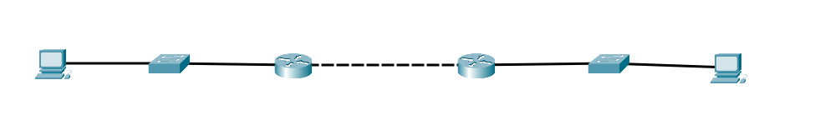
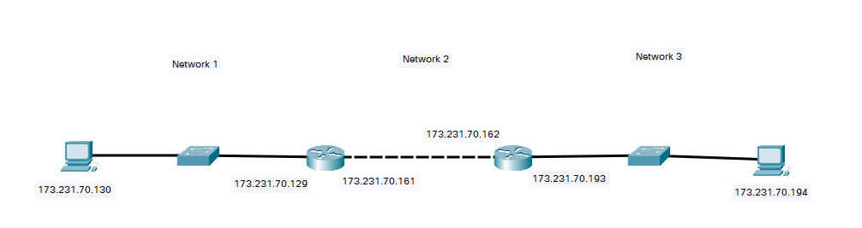
Number of needed networks: 3
Number of additional network bits: 2
Total number of networks: 4
Number of unused networks: 1
New subnet mask: /27
Network | Network Address | First Host | Last Host | Broadcast
Network 1 | 173.231.70.128/27 | 173.231.70.129 | 173.231.70.158 | 173.231.70.159
Network 2 | 173.231.70.160/27 | 173.231.70.161 | 173.231.70.190 | 173.231.70.191
Network 3 | 173.231.70.192/27 | 173.231.70.193 | 173.231.70.222 | 173.231.70.223
Network 4 | 173.231.70.224/27 | 173.231.70.225 | 173.231.70.254 | 173.231.70.255

- Subnet the following network based on the number of needed networks using the network address: 199.202.128.0/17 and address all devices
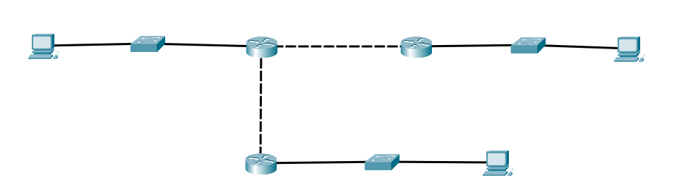
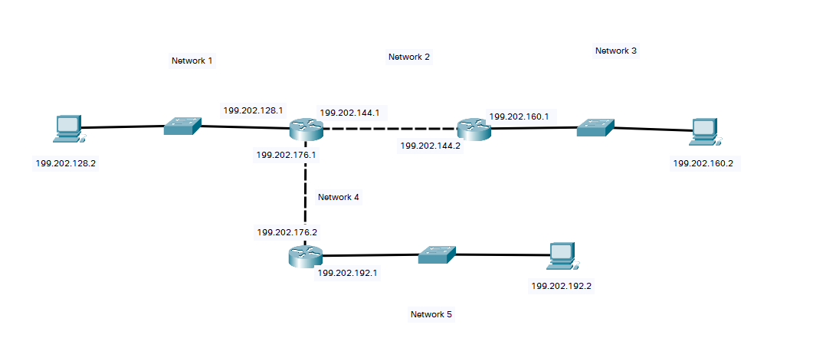
Starting network address: 199.202.128.0/17
Number of needed networks: 5
Number of additional network bits: 3
Total number of networks: 8
Number of unused networks: 3
New subnet mask: /20
Number of hosts per network: 4094
Network | Network Address | First Host | Last Host | Broadcast
Network 1 | 199.202.128.0/20 | 199.202.128.1 | 199.202.143.254 | 199.202.143.255
Network 2 | 199.202.144.0/20 | 199.202.144.1 | 199.202.159.254 | 199.202.159.255
Network 3 | 199.202.160.0/20 | 199.202.160.1 | 199.202.175.254 | 199.202.175.255
Network 4 | 199.202.176.0/20 | 199.202.176.1 | 199.202.191.254 | 199.202.191.255
Network 5 | 199.202.192.0/20 | 199.202.192.1 | 199.202.207.254 | 199.202.207.255
Network 6 | 199.202.208.0/20 | 199.202.208.1 | 199.202.223.254 | 199.202.223.255
Network 7 | 199.202.224.0/20 | 199.202.224.1 | 199.202.239.254 | 199.202.239.255
Network 8 | 199.202.240.0/20 | 199.202.240.1 | 199.202.255.254 | 199.202.255.255

- Subnet the following network based on the maximum number of needed hosts using the network address: 137.65.208.0/20 and address all devices
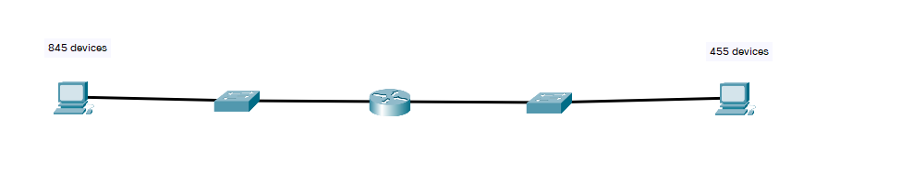
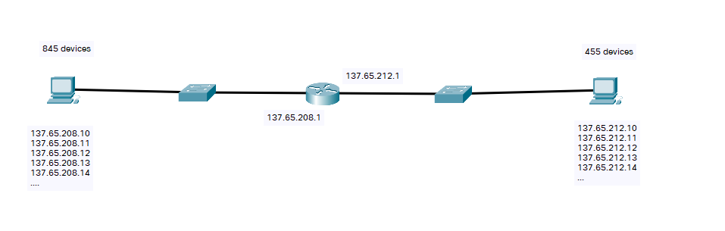
Maximum number of hosts on a network: 845
Number of needed host bits: 10
Total number of networks: 4
New subnet mask: /22
Number of hosts per network: 1022
Network | Network Address | First Host | Last Host | Broadcast
Network 1 | 137.65.208.0/22 | 137.65.208.1 | 137.65.211.254 | 137.65.211.255
Network 2 | 137.65.212.0/22 | 137.65.212.1 | 137.65.215.254 | 137.65.215.255
Network 3 | 137.65.216.0/22 | 137.65.216.1 | 137.65.219.254 | 137.65.219.255
Network 4 | 137.65.220.0/22 | 137.65.220.1 | 137.65.223.254 | 137.65.223.255

